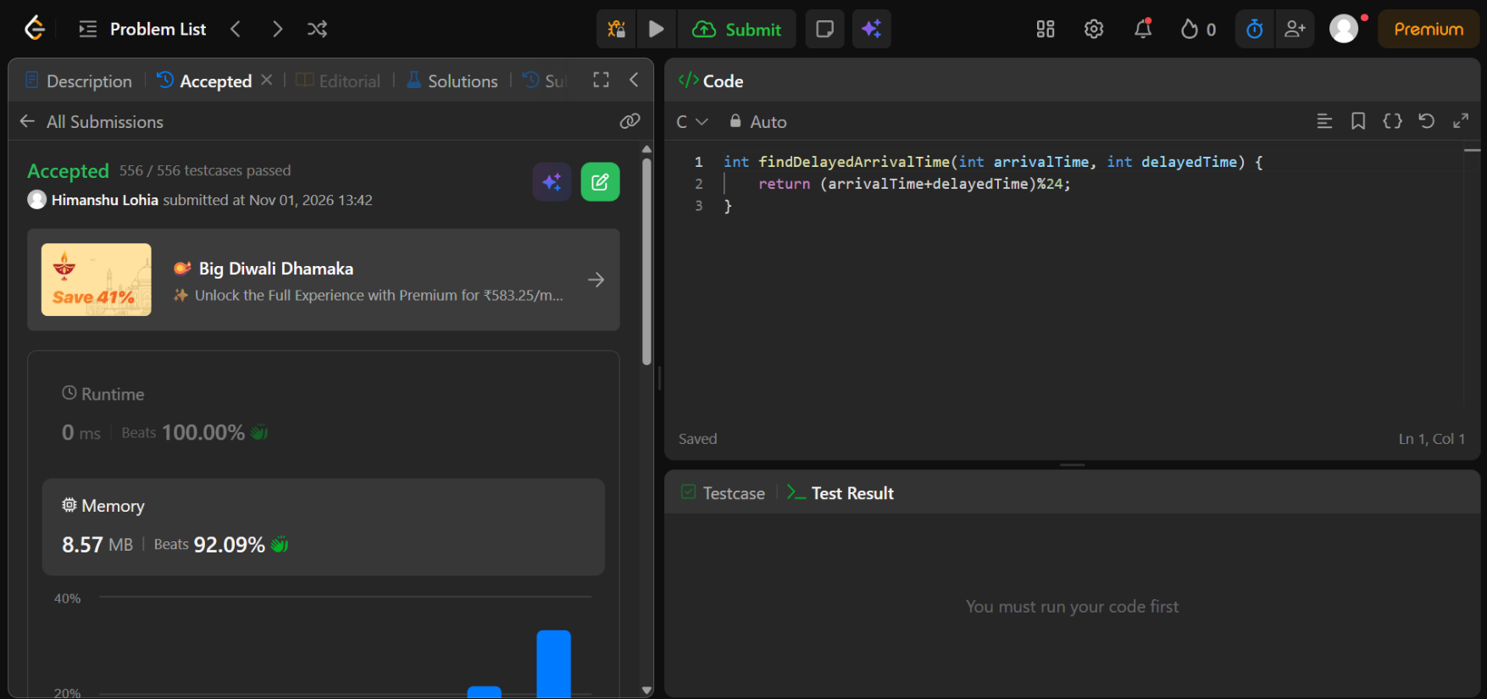
https://leetcode.com/problems/calculate-delayed-arrival-time/

int findDelayedArrivalTime(int arrivalTime, int delayedTime) {
return (arrivalTime+delayedTime)%24;
}

